Clemson University National Scholars Program | Fall 2018

Preparing for the Future

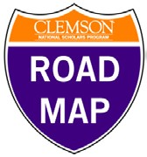
Before your scheduled advising meeting, please review your responses on last year’s Sophomore Professional Development
Plan and reflect on the following questions.

Based on your experiences, work, service, leadership, travels, and courses since this meeting last year…

- Which of your responses would now be different? How so?

2. What did your summer experience clarify for you that you do or do NOT like in terms of type of work, workplace, location, etc.?

3. What do you still not know about your intended profession or continued study that you hope to by next year this time?

4. What skills do you now know you need to strengthen further?

5. What kind of summer experience do you hope to secure next year? Where do you want to work/study/volunteer?

