# Advection Dispersion

Assuming that mass of the quantity of interest is contained within another material, designated by subscript *f*, within the control volume gives

 (1)

where *C* the dependent variable is mass per unit volume *L*f3 of the other material. Using *n* allows the material *f* to only partly fill the control volume. Typically, the material *f* is a mobile fluid.

An example of this scenario is a compound dissolved in water in a porous material. In this case, the concentration *C* is expressed per unit volume of the pore water, and *n* is porosity

 (2)

The porous material is assumed to be saturated with water in this case.

Mass flux [M/(L2T)] in a static fluid occurs by diffusion and is given by

 (3)

where *D\** is the effective molecular diffusion coefficient for the media (porous or pure fluid). 

Recalling that the volumetric flux of the fluid *f* is **q** , a component of the mass flux can occur with the fluid as **q***C* . Additional mass flux occurs by mechanical dispersion associated with the bulk movement of the fluid

 (4a)

where *D*m is the mechanical dispersion constant. The total advective mass flux is

 (4b)

The source term describes the rate of mass produced by a chemical reaction, injection, or other means

S = *Rm* (5)

where *R* is the rate of mass produced per unit volume. Substituting (3) through (5) into the conservation equation (given earlier) gives the equation for mass transport by advection and dispersion

 (6)

The advection dispersion equation is commonly simplified by combining diffusion and dispersion as

 (7)

Or



Where the hydrodynamic dispersion tensor is

 (7a)

Recall that the diffusion constant is D* in tensor form, and Dm is the mechanical dispersion. The mechanical dispersion results from physical mixing of mass within the flow. This can occur where the velocity varies normal to the direction of flow, such as the variation near the wall of a pore. In this case, molecules that are close to the wall would move slower than molecules being advected near the center of the pore. This causes the concentration to spread in the direction of flow by *longitudinal dispersion*. In a porous media, flow paths at the pore scale commonly split as the flow goes around a solid grain, and this causes mass to spread transversely relative to the flow direction.

It follows that the mechanical dispersion, **Dm**, depends on the longitudinal dispersivity, L, and the transverse dispersivity, T, as well as the velocity of the flow. The mechanical dispersion tensor in 3D is (Bear, 1979; Burnett and Frind, 1987)

 (8)

This is the form used by Comsol.

## 1D Case

It will be useful to examine a simplified case where the flow is 1D parallel to the x-axis, so *u* is constant and uniform, and *v* = *w* = 0. In this case, (8b) becomes

 (9)

Expanding the del operator in (7) for 1D and using (9) gives

(10)



Dividing through by porosity, *n*, and recognizing that the average linear velocity is related to the flux using **u***=***q***/n* gives

 (11)

Where *v*x=*q*x/*n*, and then rearranging slightly

 (12)

The sum of the diffusion constant and the mechanical dispersion is the hydrodynamic dispersion

 (13)

We used the tensor form for *D* in (7a) but in (13) we can simplify and use the scalar because the problem is only 1D.

Substituting (13) into (12) gives a simple form of the advection dispersion equation that is often used in textbooks.

 (14)

### Dimensionless Form and Scaling

The dimensionless form of (14) can be obtained by multiplying both sides by *L*2/(*C*o*D*)

 (15)

where *L* is a characteristic length of the problem, *C*o is a characteristic concentration, and *D* is the dispersion constant. Recognizing the following dimensionless groups

 (16)

where *R*’ is the dimensionless source, *C*’ is the dimensionless concentration, and *x*’ and *t*’ are the dimensionless spatial coordinate and time. It follows that the characteristic time is defined by *t*c= *D*/*L*2. Using the dimensionless groups in (16) in (15) gives

 (17)

Or in multiple dimensions

 (18)

where Pe is the Peclet number,

 (19)

And

 (20)

is the first Damkohler number.

The analysis outlined above is an example of scaling of a process by characteristic quantities. In general, the characteristic quantities depend on the details of a particular problem. The characteristic length, L, is commonly an actual dimension of the problem. Analysis of flow in a pipe might use the diameter of the pipe as the characteristic length, for example. Using a characteristic length in a problem allows you to determine the meaning of “small” and “large” in a problem because those terms will implicitly be comparing to the characteristic length.

The characteristic time will also be problem dependent, and it is common for individual processes to each have a characteristic time. This is intuitively appealing if you consider that a characteristic rate is the inverse of the characteristic time. So, in a problem involving multiple processes, it seems reasonable to expect the rates of some processes to be faster than others and this is expressed in the characteristic time for the process.

Whereas the characteristic length outlined above is an actual length, the characteristic time is often not an actual time, but instead it is a combination of other terms that has units of time.

To see how this works, we recall that transport problems involve advection, diffusion, and reaction. We expect these processes to operate at different rates and to have different characteristics times. The characteristic time for advection should be related to the velocity of the flow, so we propose that the characteristic time for advection is the ratio of the characteristic length to the velocity. The characteristic times for diffusion and reaction are scaled to D and R, respectively. So, the characteristic times are

 (21)

The next step is to the three characteristic times to create three dimensionless ratios. A convenient way to think about this is that the processes are represented by their characteristic rate, which is the inverse of their characteristic time. This is important because these dimensionless ratios will control the basic behavior of the transport problem.

The ratio of advection to diffusion rates is called the Peclet number. The ratio of advection to reaction rates is the first Damkohler number. The ratio of reaction to diffusion is the second Damkohler number.

 (22)

These dimensionless numbers provide a simple basis for evaluating the processes that are important relative to other processes. For example, where *Pe*>>1, advection rates are much faster than diffusion (or dispersion). In this scenario, advection is much faster than diffusion, but if both diffusion and advection are required for the process to occur, then *Pe*>>1 means that diffusion will limit the overall rate. Likewise, advection will limit the overall rate where *Pe*<<1.

Similarly, where *Da*I>>1, the reaction rate is fast compared to advection, so advection will control the overall rate. This could occur, for example, in a chemical reactor where the reaction was fast so the overall rate was controlled by the flow rate through the reactor.

*Da*II>>1 means that the reaction rate is fast compared to the rate of dispersion. In many systems, dispersion or diffusion is required to bring reactants close enough so the reacting molecules can interact. So, *Da*II>>1 implies that the overall reaction rate is limited by dispersive mixing, whereas *Da*II<<1 implies that the overall rate is limited by the rate of the basic chemical reaction.

## Turbulent Flow

The velocity distribution during turbulent flow can be conceptualized as the sum of an average velocity and the instantaneous deviation from the average. The concentration can be conceptualized the same way, so

 (23)

Where the term with an overbar is the average value and the primed term is the deviation from the average. Substituting (19) into (14), and using *D*\* instead of *D* because the fluid is continuous so there are no pores to contribute to *D*m

 (24)

Where the porosity, n, is 1 because we assume the turbulent flow is all fluid. Rearranging

 (25)

Averaging the primed terms with time gives a result that is zero. This is because the primed terms fluctuate about the average values, which are represented with the overbar. The red terms below contain a single primed variable, a fluctuation, so taking the time average of (25) will cause these terms to go to zero, while the other terms are unaffected.

 (26)

However, the product of two fluctuating quantities does not necessarily have a time average that is zero, even though the average of each of the two quantities is zero. This could occur, for example, if the variables were uncorrelated. The result is that the two terms on the right side that are products of fluctuations remain after averaging with time, while the red terms go to zero. Terms that only include average values are unchanged by time averaging. So, (26) reduces to

 (27)

The terms and are mass fluxes due to fluctuations in concentration and velocity. The product is a mass flux, and we assume the mass flux is proportional to the concentration gradient in the direction of flow

 (28)

where *e*x and *e*y are called the mixing coefficients (Logan, 2012) or the turbulent diffusivity (Bakker, 2013). Regardless of their name, these terms relate mass flux to concentration gradient and have units of *L*2/*T*, so they are analogous to a diffusion constant or a mechanical dispersion constant. Substituting (28) into (27)

 (29)

And then grouping terms as before

 (30)

And rearranging

 (27)

This is the same form as the equation derived for porous media (e.g. eq. 14).

The result of the analysis outlined above shows that transport that occurs by advection and dispersion in porous media can be analyzed using an equation that has the same form as the one used when transport takes place through a continuous fluid in laminar or turbulent flow. Details of the dispersion process, and how the dispersion constant is determined, will vary, but the basic form of the equation is independent of the flow process.

### Hydrodynamic Dispersion

The hydrodynamic dispersion, *D*, is the sum of molecular diffusion and a mechanical dispersion term. Molecular diffusion depends on size of the molecule that is diffusing, the viscosity of the fluid where the diffusion is occurs, temperature, and other factors. Molecular diffusion constants can be estimated using the Stokes-Einstein relation



(28)

where *k*B is Boltzmann’s constant, *T* is absolute temperature, *r*c is the radius of the particle (e.g. molecule or atom) that is diffusing, and  is the dynamic viscosity of the fluid through which diffusion is occurring. The diffusion constant can also be measured experimentally, and some example values are given below

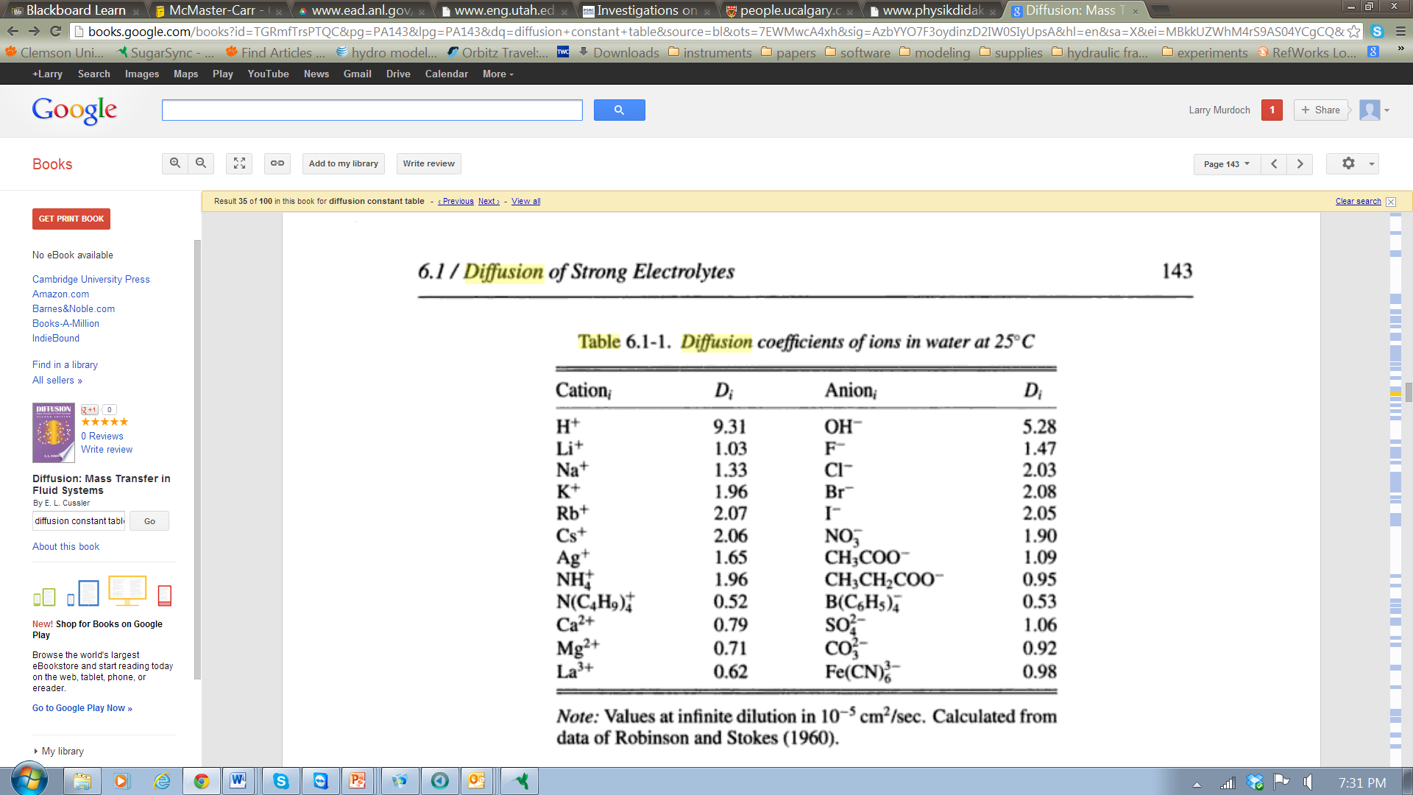

General guidelines are that the diffusion of small ions through water (as in the table above) is governed by a diffusion constant of . Diffusion through gases, like air, is  and diffusion through solids is .

### Mechanical Dispersion

The mechanical dispersion results from mixing in a flow that occurs at scales that are too small to consider explicitly in an analysis. In general, mechanical dispersion is

 (29)

where *v*c is a characteristic velocity and *L*c is a characteristic length for the problem. Mixing is caused by irregularities in the flow, so it is reasonable that mechanical dispersion is characterized by the product of a characteristic velocity and length for the problem. The length scale is related to the size of the irregularities in the flow, and the velocity of the flow contributed to the rate of mechanical dispersion.

Mechanical dispersion increases with the size of a problem domain. Conceptually, this is because the size of the structures in the flow that cause dispersive mixing increase as the problem domain increases. For example, the longitudinal dispersivity L in porous media is approximately 1/100 to 1/10 times the characteristic length of the transport path in experiments. This occurs because the size of the geologic structures that contribute to dispersion increase with the size of the region where transport occurs.

Mechanical dispersion in turbulent flows in pipes and channels is also given in general by (29), but the details depend on the configuration of the problem. Effective mechanical dispersion is often related to the “shear velocity” in a channel or pipe. Shear velocity is

*u*sh=(o/)1/2

where o is the wall shear stress. In general, the wall shear stress is and could be calculated from the velocity distribution at the wall or bed. In some cases, the wall shear stress can be calculated, and an example of this is on the bed of a uniformly sloping, wide channel where



where *S* is the slope of the channel, and *d* is the depth, *g* is gravity. A compilation of the mechanical dispersion in various scenarios is given below.



Laminar flow, pipe:

Turbulent pipe: *D* = 10.1 *R u*sh;

Longitudinal Turbulent pipe: *D* = 0.5*dv*

Transverse turbulent pipe: *D* = 0.0016*dv*

Porous media: *D* = L*u;* L≈(0.01to 0.1)*L*  *L*= characteristic length

Infinitely wide channel: *D=5.93 d u*sh; *d* = depth

Vertical mixing in stream: *D=0.067 d ush*

Longitudinal in stream: 

Longitudinal in air, parallel to the ground: *D* = 0.005 *uL*

Sorption kinetics

|  |  |
| --- | --- |
| First order |  |
| kth order |  |
| Langmuir kinetic |  |
| Langmuir with competition |  |
| Elovich |  |
| Power |  |
| *C*f: concentration of *s*1 in fluid [*M*s1/*L*3f]; *C*s concentration on solid [*M*s1/Msolid]; *k*ads: sorption rate constant[units vary], *k*des: desorption rate constant [1/T], : porosity [L3w/L3T], : bulk density[*M*solid/*L*3T], *P* constant [*L*3f/*M*s1]  Limousin et al. (2007) http://www.sciencedirect.com/science/article/pii/S0883292706002629# | |

